Name: Syed Arham

Roll No: 24k-2551

BSE-2A

Q1:-

Q2:-

Q3:-

Q4:  
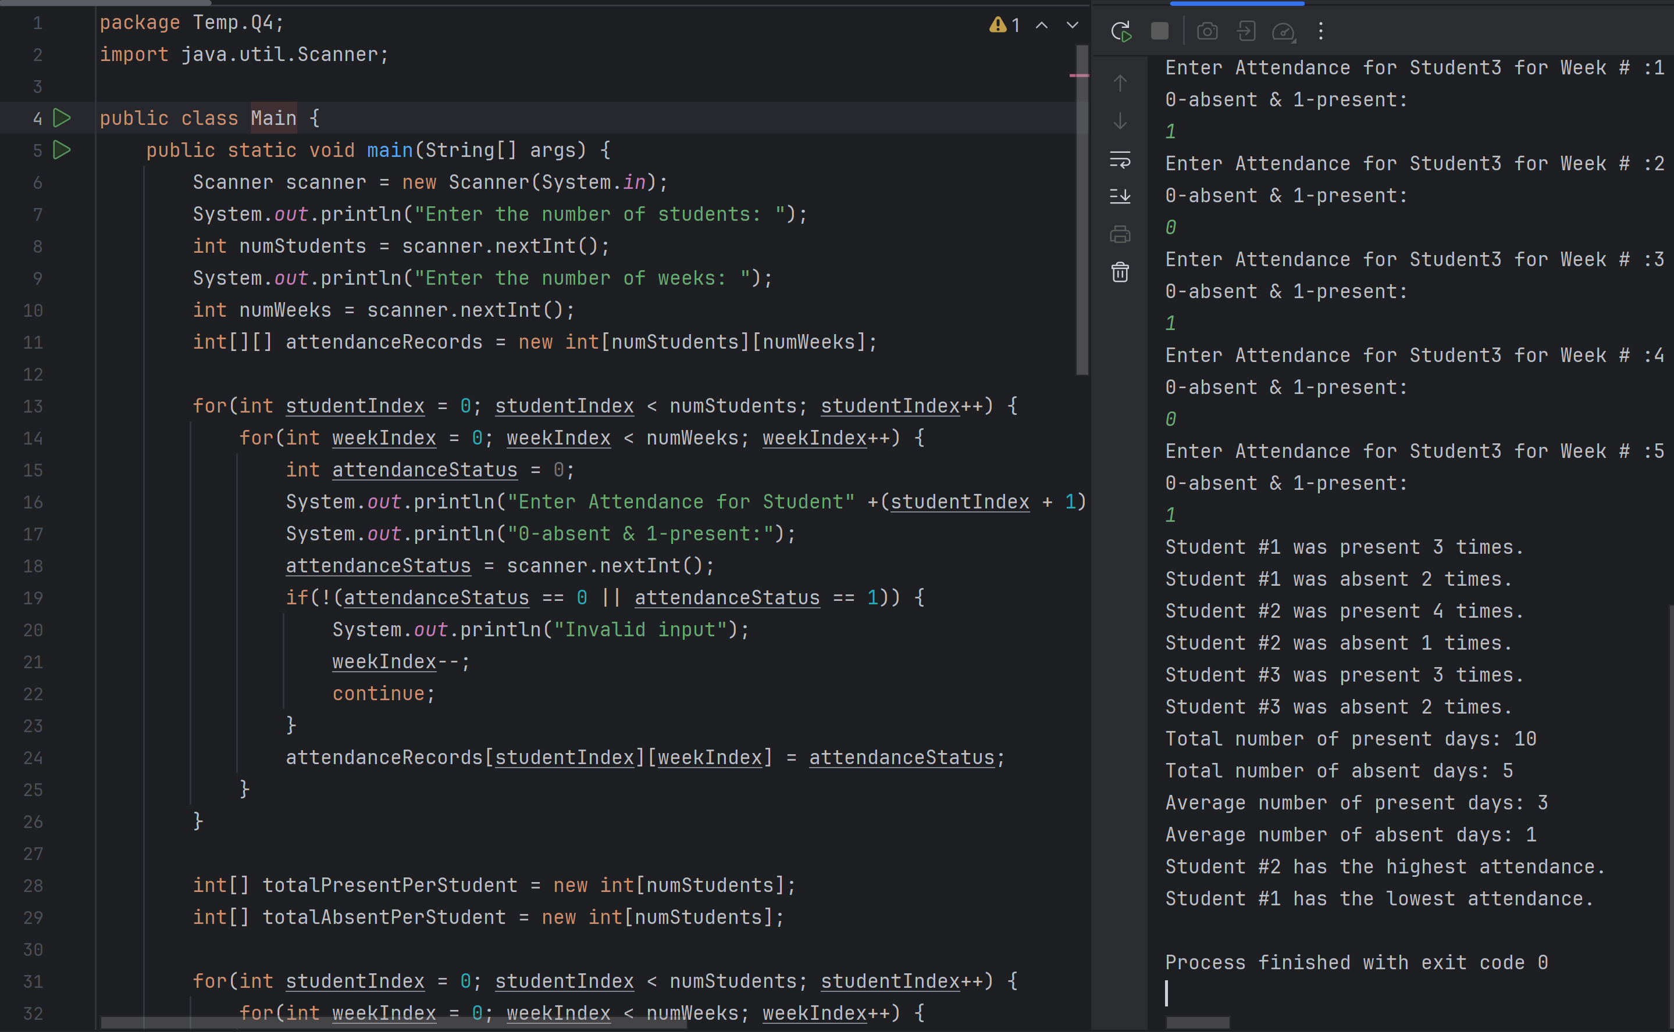

Q5:-

Q6:-  
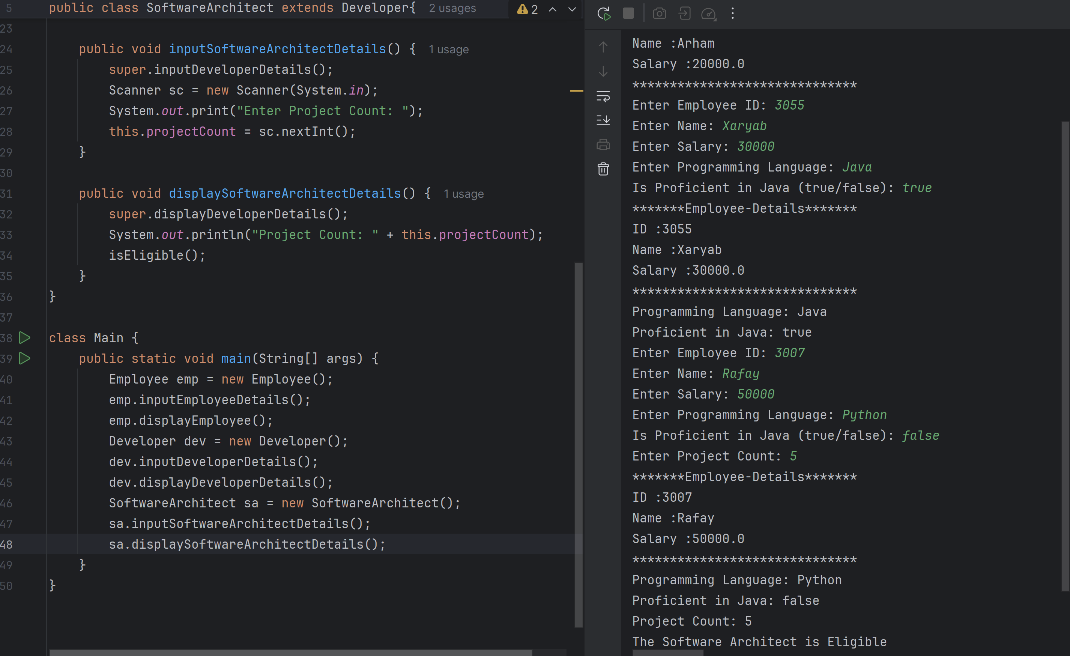

Q7:-  
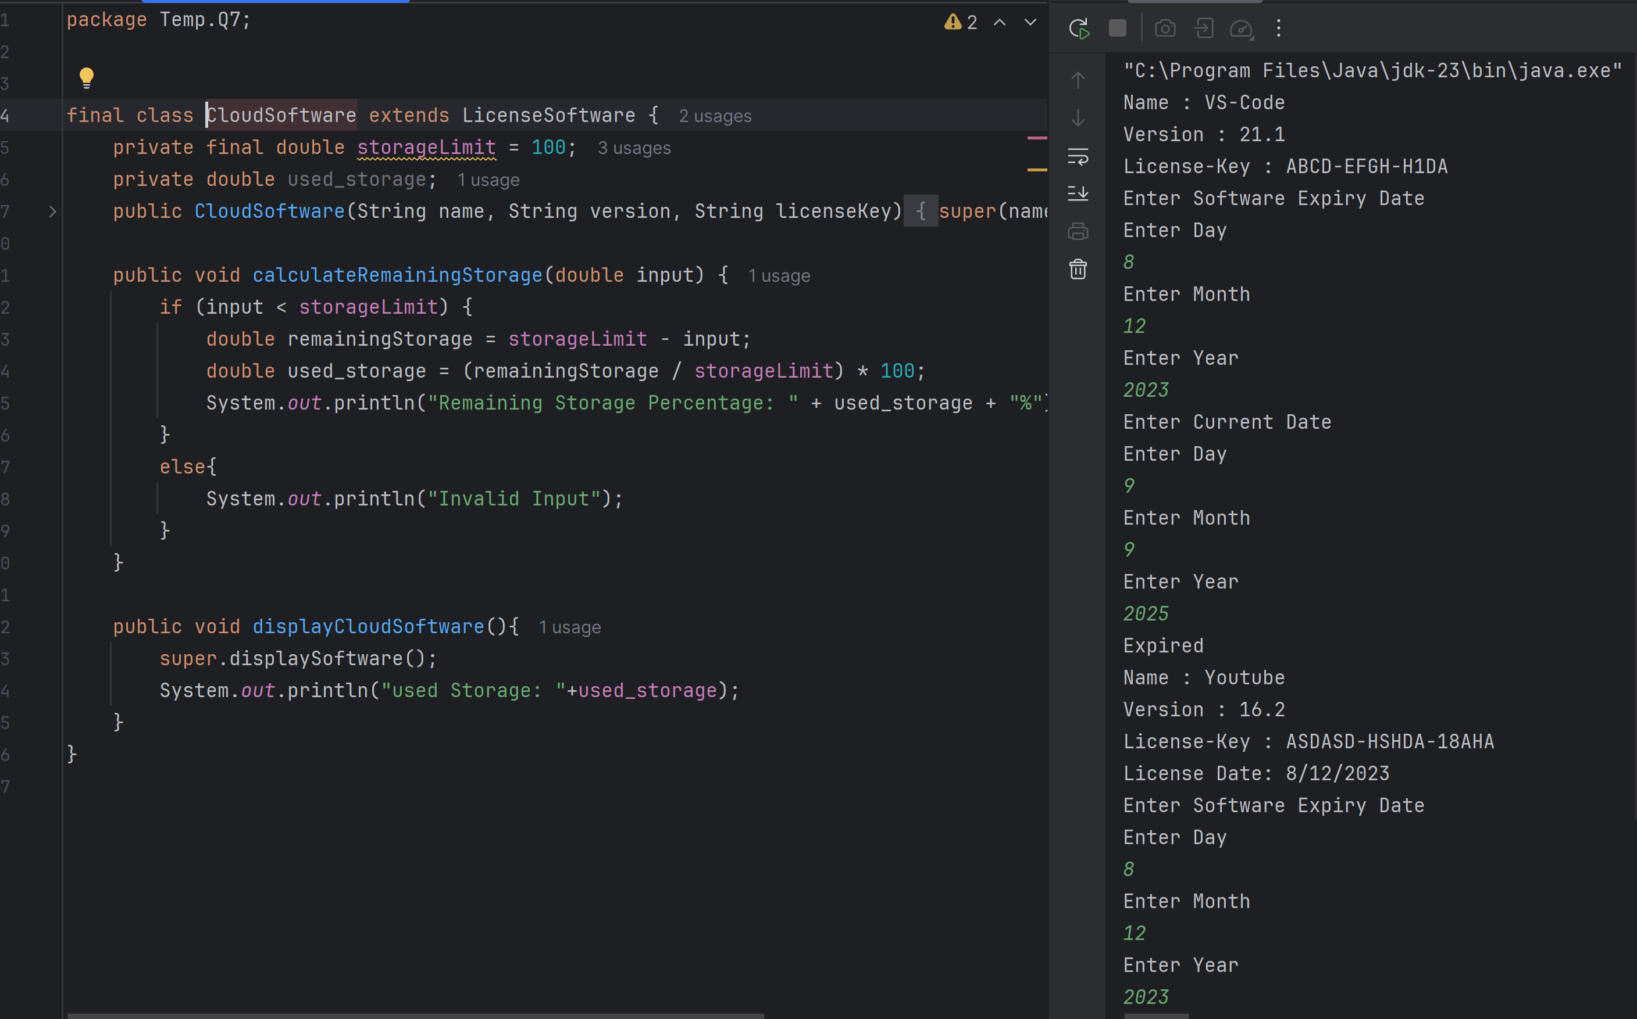

Q8:-  
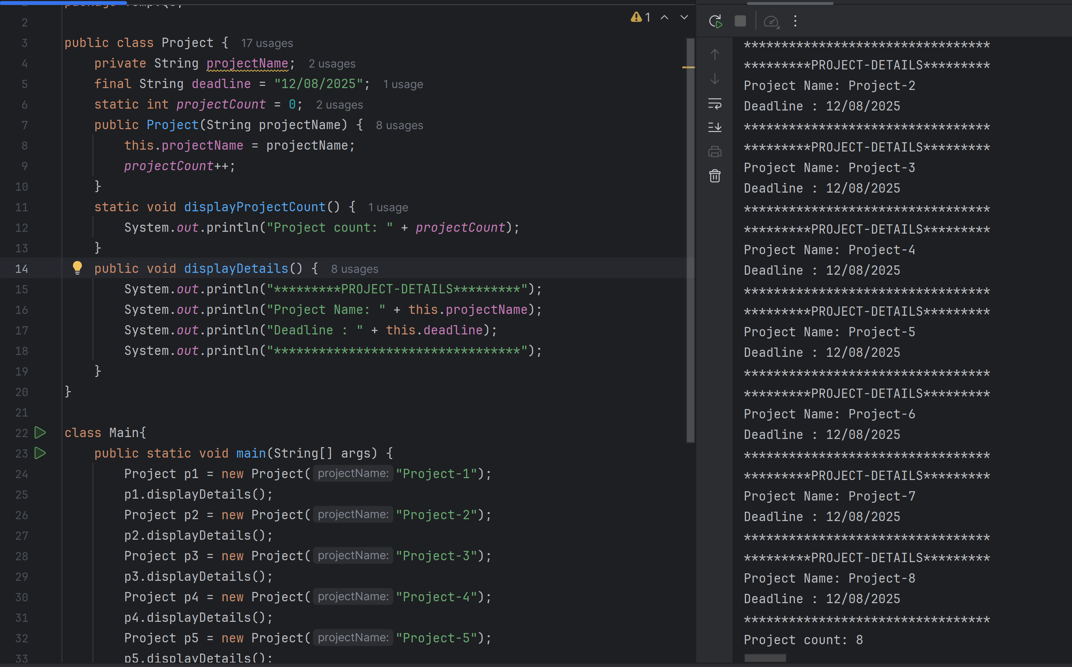

Q9:-  
